Содержание
Четверть 1
- Контроль навыков аудирования и чтения по теме «Образ жизни?». Mодуль 1. стр 3
Spotlight 7 Listening ,Reading (TB)
- Контроль лексико- грамматических знаний по теме «Образ жизни». Модуль 1 стр 5
Spotlight 7. Testbooklet 7 m1 (A,B,C,D,E, F, )
- Контроль письма и говорения по теме «Время рассказов». Модуль 2 стр 8
Spotlight 7. Testbooklet 7 m2 ( A,B,C,D,E, )
Четверть 2
1) Контроль навыков аудирования и чтения по теме «Внешность и характер». Mодуль 3 стр 11
Spotlight 7 Testbooklet 7 m3 (TB)
2) Контроль лексико – грамматических навыков по теме «Внешность и характер» Модуль 3. стр 14
Testbooklet 7 m3 (A,B,C,D.E, F,)
3)Контроль навыка говорения и письма по теме «Об этом говорят и пишут» Модуль 4. стр 17
Testbooklet 7 m4 ( A,B,C,D,E, F, )
Четверть 3
- Контроль лексико- грамматических знаний по теме «Что ждет нас в будущем». Модуль 5. стр 20
Spotlight 7 Testbooklet7 m5 ( A,B,C,D,E, )
- Контроль навыков аудирования и чтения «Развлечения» Модуль 6 стр 22
Testbooklet 7 m6 (J, I)
- Контроль лексико- грамматических знаний по теме « Развлечения». Модуль 6 . стр 25
Testbooklet 7 m6 ( A,B,C,D,E, F, G,)
4) Контроль навыка письма и говорения по теме «В центре внимания» Модуль 7. стр
Testbooklet 7 m7 ( A,B,C,D,E, F, G,H)
Четверть 4
1) Контроль лексико- грамматических знаний по теме «Проблемы экологии». Модуль8. стр 20
Spotlight 7 Testbooklet7 m8 ( A,B,C,D,E,F )
2)Контроль навыков чтения и аудирования «Время покупок» Модуль 9 стр 28
Testbooklet 7 m9 (I,J,)
3)Контроль лексико- грамматических знаний по теме «Время покупок». Модуль 9 стр 33
Testbooklet 7 m9 (,A,B,C,D. E.F,G,)
4)Контроль навыков говорения и письма по теме «В здоровом теле-здоровый дух ». Модуль 10. стр 30
Testbooklet 1 m10 (A,B,C,D,E,F,G,)

Ключи -----------------------------------------------------------------------------------------------------------------------------------------стр 36
Критерии оценивания ----------------------------------------------------------------------------------------------------------------------стр

Контрольно-измерительные материалы по английскому языку для 7 класса по УМК «Английский в фокусе» (Spotlight ) за I четверть.
Spotlight 7. Модуль 1 «Lifestyles» (Образ жизни).
1.Контроль навыков чтения и аудирования по теме «Образ жизни». Mодуль 1.
H Read the text and mark the sentences T (true) or F (false).
Safety on the School Bus
Every year, children are injured because they have not learned a few basic rules about school bus safety. Many people believe that children are most often hurt while they are on the school bus. However, this is not true. Most accidents take place when the child is outside the bus, not inside. Of course, some injuries occur because of crashes, but most of them happen when children are in the blind spots around the bus; they occur when the children are hidden from the driver’s view.
To avoid accidents, children should learn to obey a few simple rules. Firstly, they should always keep a safe distance between themselves and the tyres or the rear of the bus. Secondly, in cases where children need to cross the road when they get off the bus, they should walk at least three metres in front of the bus and then wait for the driver to signal to them that it is safe to cross to the other side of the roadway. In addition, when waiting for their bus to arrive, children should stand well away from the road. Finally, they should never try to get on or off the bus until it has come to a complete stop and the driver has opened the doors.
1 Most accidents happen after the child has got on the bus.
2 Some children are hurt when their bus hits another vehicle.
3 All buses have blind spots.
4 Some children hide from the driver and then get injured.
5 Children should never go too near the back of the bus.
6 Children should cross 3 metres behind the bus when they get off.
7 Before they cross the road, they should look at the bus driver.
8 Children must wait a certain distance from the edge of the road.
9 Children shouldn’t try to board a bus until it has stopped moving.
10 They must wait for the driver to tell them it is OK to get on the bus.

I Listen to two friends talking about safety in the home and complete the gaps.
Safety in the Home
- At night, keep your mobile phone beside your 11) ……. (And make sure it’s switched on!)
- In your 12)….….., there should be dusk-to-dawn outside lights, 2.5 metres 13)….….or more.
- If a 14) ….…. comes to your door, always ask for ID.
- Remember, if you’re not 15) ….…… don’t let them in!

2)Контроль лексико- грамматических знаний по теме «Образ жизни». Spotlight 7. Модуль 1
A Match the words/phrases to their definition.
1 ID ……… A look for information on the computer
2 computer games …… В a sport
3 beach volleyball ……….. C a machine that signals danger
4 surf the Net E identification ……… ..
5 alarm system F fun activities on the computer
В Match the words to form phrases.
6 install ……. A landscapes
7 high-quality …….. В unemployment
8 high rate of …….. C isolated
9 feeling …….. E an alarm
10 beautiful …….. D lifestyle

C Complete the sentences with the correct word.
*heavy *cost *helpful *crowded * convenient *peace
E.g. In a big city, you will always find convenient public transport
11 We went for a walk in the country, because we needed some ………………. and quiet.
12 She spent the day in London, but found the streets very ………………
3 In the country you usually meet friendly and people.
14 My father hates driving in ………………… traffic.
15 I love living in the city, but I don’t like the high …………… of living.
D Fill in the correct preposition.
*after *into *of *on *out *over
E.g. Keep your mobile phones switched on at night.
16 If a burglar breaks into your house, always hand………..your valuables.
17 I ran ……….. an old friend at the supermarket yesterday.
18 We ran out ……….. milk, so can you buy some when you’re at the supermarket?
19 My brother and his friends hang………….at the shopping centre on Saturdays.
20 I saw two policemen running ……………. a robber.
E Put the verbs in brackets into the Present Simple or the Present Continuous.
21 We ………………..(feed) the chickens every morning at 6:30.
22 He…………..(think) of changing his job.
23 I really have to go now. My plane …………….. (leave) at 10:30.
24 We …………………(go) to the cinema tomorrow afternoon. Would you like to come with us?
25 I………….(study) in my bedroom at the moment, but I can join you in the park later.
26 Hurry up! The play………………….. (start) in ten minutes.
27 He………………….(leave) early in the morning every Friday.
28 I ……………………(cook) dinner this evening, so please don’t be late.
29 She……………..(visit) her grandmother every Sunday afternoon.
30 He ………………..(write) a book about the high cost of living.
F Use the prompts to give the correct advice, using either should or shouldn’t.
E.g. A: I’m really tired today
B: (bed/early tonight) You should go to bed early tonight.
31 A: I lost my red pen. B: (keep/pencil case)
32 A: I feel really sick. B: (play/outside).
33 A: I’ve got a toothache. B: (see/dentist) …………
34 A: I’m very worried about my exams! B: (worry so much) ……………
35 A: I broke my brother’s new camera. B: (tell/tonight)………………..

Spotlight 7. Модуль 2 Tale Time (Время рассказов).
3)Контроль письма и говорения по теме «Время рассказов». Spotlight 7. Модуль 2

A Match the types of stories to their descriptions.
1 An exciting story about a hero who does dangerous things. … – A mystery
2 A serious and emotional play written for the theatre, radio or television. … – В biography
3 A story which makes you feel worried, because you don’t know what is going to happen next. … – C humorous story
4 A funny story with a happy ending. … – E adventure
5 A story about someone’s life written by another person. … – F suspense story
6 A story about a crime or a strange event. … – G drama
В Fill in the correct word.
• explore • glance • cosy • hide • initials • famous • solve • imagination • intelligent
• compass
E.g. Jane travelled to several countries.
7 What can we do to …………. the problem of unemployment?
8 Sherlock Holmes was a ………..detective.
9 Jules Verne had a wonderful …………
10 At first ………… it looked like a wolf, but it wasn’t.
11 Diane is an extremely ………….. child and the best student in her class.
12 I love your flat! It’s nice and ……….. .
13 Let’s …………. the woods before it gets dark.
14 Where did you ………… the money? I can’t find it.
15 Let’s use a ………….. to find our way back. 16 This is my father’s shirt. It’s got his on it.
C Put the verbs in brackets into the Past Simple.
17 Jules Verne …… …….. (write) Twenty Thousand Leagues Under the Sea.
18 Sherlock Holmes …… …… (smoke) a pipe.
19 Miss Marple ….. ……. (catch) many criminals.
20 …… …….. (Hercule Poirot/live) in Belgium?
21 How …… …… (Captain Nemo/travel)?
22 …… ….. (Dr Watson/help) Sherlock Holmes?
23 Agatha Christie … ……. (create) the Belgian detective, Hercule Poirot.
24 The professor and Axel …………(find) a mysterious message.
25 Arthur Conan Doyle ……….. (be) a famous writer.
26 Dr Frankenstein ….………. (meet) Captain Walton on the ice.
D Underline the correct item.
27 The cat ran away until/as soon as it saw the dog.
28 Henry used to go/went to Ireland last week.
29 We used to go/go to the park on Saturdays, but now we go swimming.
30 We were surprised when/until we saw Mum on television.
31 Lyn got a job after/until she finished school.
32 First she made dinner, then/when she watched TV.
33 The children played in the garden until/then it got dark.
E Choose the correct response.
E.g.I had quite a shock. D A What? Tell me!
34 You’ll never guess what happened to me ….. В No, you certainly don’t
35 There was a snake in the fountain. … C Oh my goodness!
36 You look a little upset. … D Really? Why?
37 Well, you don’t see that every day, do you? … . E Luckily, no.
38 Was anyone hurt? … F Well, I had quite a shock.

Контрольно-измерительные материалы по английскому языку для 7 класса по УМК «Английский в фокусе» (Spotlight7) за II четверть.
Spotlight7 . Модуль 3 «Profiles» (Внешность и характер).
1)Контроль навыков аудирования и чтения по теме «Внешность и характер».

I). Listening and choose the correct answer.
e.g. What does Alice look like today?
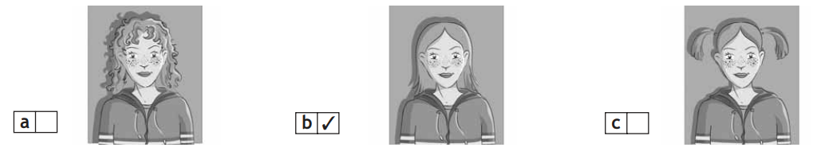
1. What does Sally enjoy doing the most?
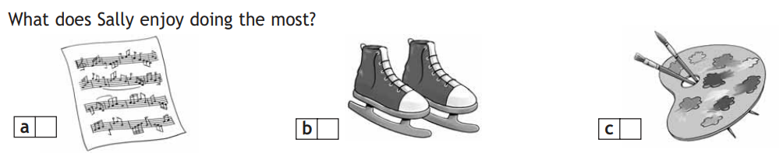
2. Where did Lori and Kimberly go?
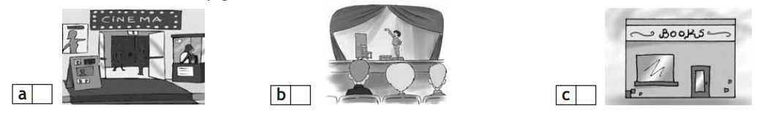
3.What is Annabel’s hair like?
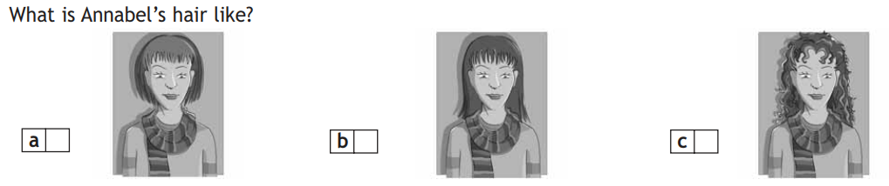
4. What do Emily and Gloria decide to do?
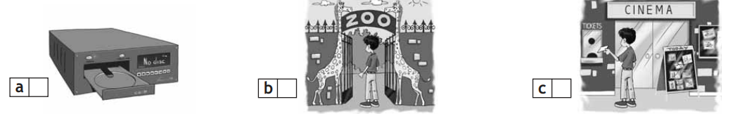

5.Who are Tara and Adam talking about?
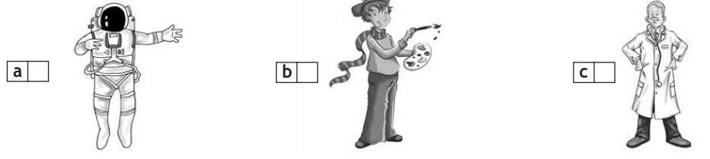

H). Read the following text and mark the statements T (true) or F (False)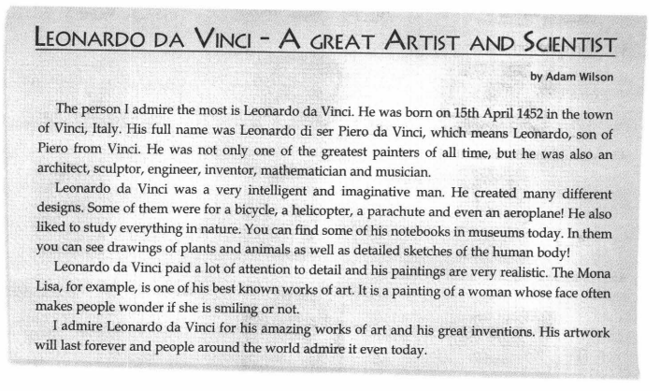
6. His father’s name was Paolo. …..
7. He designed a parachute. …..
8. None of Da Vinci’s notebooks survive today. ….
9. Da Vinci studied the human body. …..
10. Some people can’t tell if the Mona Lisa is smiling. …..

2) Контроль лексико – грамматических навыков по теме «Внешность и характер!» (Модуль 3).
A). Fill in the correct word.
• determined….. • curious…… • daring….. • patient…• athletic…
1 Don’t be so …… ! if he wants to tell you what happened, he will.
2 My sister is very …… …… . When she wants something she does everything she can to achieve it.
3 Be ……. ! We’ll be out of here in a minute.
4 Michael goes skateboarding in winter and windsurfing in summer. He is very.
5 We did something …….. last weekend. We went bungee jumping!
В). Underline the correct item
6 John is the young boy with the spiky/skinny blond hair.
7 Mum and Dad both have dark appearances/tans.
8 Justin and Julian are both well-build/well-built.
9 Claudia has a pretty face with brown, wavy eyes/hair.
10 My baby sister has cute pigtails/face.
11 My brother has long/big hair.
12 My uncle is really tall with a moustache/hair.
13 Adam has freckles/beard on his face.
14 My hair is shoulder-length/tall.
15 You have green eyes and curly/round blond hair.
C). Complete the sentences using the correct relative pronoun or relative adverb.
E.g. Jane, whose favourite hobby is fencing, also loves swimming.
16 I am talking about the girl ….…… has long brown hair and green eyes.
17 This is the skate-park ……… people come to skateboard.
18 He tried to explain ….…… he did such a thing.
19 The girl …………. hair is curly is my elder sister.
20 2001 was the year …………. we played in the chess tournament.
D). Complete the sentences using the correct form of the word.
21 I found the book really …………. . (bore)
22 Dad said he was really …… ….. in us. (disappoint)
23 The lesson was really …… …….. . (interest)
24 Jane is always ………….. after work. (tire)
25 Jack is …… …….. of spiders. (scare)
E). Put the adjectives into the correct order to complete the phrases.
26 • English • nice • middle-aged
a(n) ……………..… … writer
27 • Japanese • young • interesting
a(n) …………… …… student
28 • famous • Russian • well-built
a ………………… …… boxer
29 • tall • French • easy-going
a(n) ………….…..…… actor
30 • talented • teenage • Italian
a(n) …………………….. artist
31 • German • pretty • intelligent
a(n) ………………..…… scientist
F). Complete the sentences using back, away or up.
32 John gave ….. ….. boxing two years ago because of a bad injury.
33 Give me …..….. my skateboard!
34 Shelly gave …… ……. her book collection to the school library.

3)Контроль навыка письма и говорения по теме «Об этом говорят и пишут!» (Модуль 4).
A). Fill in the correct word/phrase.
• chat show • weather report • interview • documentary • cartoon • news
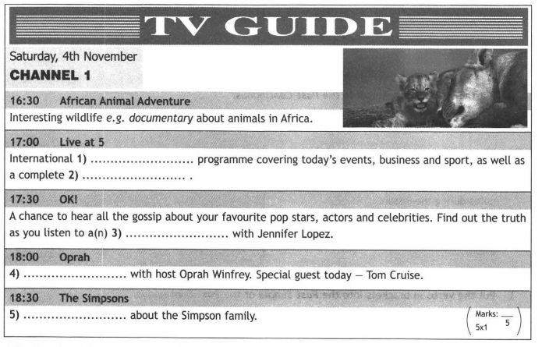
В). Complete the sentences with the correct word.
….. • gossip• fashion• music• text messages• Horoscopes
6 My sister buys a popular magazine to read …….. about famous people’s lives.
7 The …… …….. programme plays all the latest hits.
8 …… …….. try to tell you what will happen in the future.
9 Polly likes to send ….. …….. to her friends.
10 Jane buys Sugar magazine for its …… ……. advice.
C). Underline the correct word.
11 John brave/bravely fought the bear.
12 The zebra ran off/went off before I could take a photograph.
13 I was surprised/surprising to hear I won the competition.
14 It can be difficult to come on/up with new ideas.
15 Mark was very exciting/excited when he won the writing award.
16 What does the weather article/report say?
17 Glossy magazines are attractive/popular to teenagers.
18 I like the fashion and beauty advice/strips in this magazine.
19 In sports, it’s a great achievement to attend/break a world record.
20 This belt really goes with/on your shoes.
D). Put the verbs in brackets into the Past Continuous.
21 We …..….. (plan) to go to the zoo, but we stayed home instead.
22 Jackie ………… (take) notes during the lesson.
23 The students …………. (work) hard because they wanted a good mark in the exam.
24 What ………….(you/do) last night?
25 He ……. …….. (play) with his nephews all day Saturday.
E). Put the verbs in brackets into the Past Simple or the Past Continuous.
26 Gary …… ……..(ride) his bicycle while Alan was skateboarding.
27 The policeman asked, “What …… …….. (you/do) at the time of the robbery?”
28 I ……... (pass) the exam without difficulty.
29 Mum ………….. (cook) dinner before dad came home.
30 She …… …… (write) a letter when the lights went out.
31 They ….. …….. (go) on holiday in June.
32 A woman from Vancouver …… .. (find) a bear in her kitchen.
33 When I was a teenager I …………. (play) in the school basketball team.
34 My aunt Jane ………….. (drive) to Oxford when I phoned her.
35 Paul ………….. (get dressed), had breakfast and then went to school.
F). Choose the correct response.
36 You won’t believe this. I found a wallet in the street. – A How dreadful! Was she hurt?
37 I broke my leg and can’t play in the match. – В What a story! How did they do that?
38 Listen to this — Helen had a car accident! C Wow! How long did it take you?
39 Did you hear about the chimpanzees that sailed across the Atlantic? – D Oh dear! I hope you get well soon.
40 I climbed Mount Everest. – E Really? Did you take it to the police?

Контрольно-измерительные материалы по английскому языку для 6 класса по УМК «Английский в фокусе» (Spotlight 7) за III четверть.
Spotlight 7 module 5. « Что ждет нас в будущем?». What the future holds?
1)Контроль лексико- грамматических знаний по теме «Что ждет нас в будущем?». Spotlight 7. Модуль 5.
A) Complete the words.
1. l _ _ t _ p
2. _ u t _ _ n
3. a _ s _ g _ me _ _
4. _ a d _ _ t s
5. s _ b _ a _ _ n _ s
В) Match the words in Column A to the words in Column B.
e.g. ditigal C Camera
6. virtual A) dome
7. mobile В) car
8. flying D) phone
9. MP3 E) pet
10. glass F) player
C) Fill in the correct word/phrase.
•pocket money •role model •Computer simulation •training •button
11. Press the …… …….. to switch the computer on.
12. This singer is a good …… ……… for teenagers.
13. You must save your …… ……… if you want to buy something special for yourself.
14. This college offers many courses in teacher …… ……. .
15. ……. ……….. is used a lot in video games.
D) Underline the correct form of the verb.
16. Maybe I’ll go/am going to bed early tonight.
17. Look at those black clouds! It’s probably going to/will rain.
18. I promise I am going to/will feed the cat.
19. I will/am going to order a pizza if you like.
20. I want to buy a new video game so I’ll/’m going to save my pocket money.
E) Write the correct form of the verb in brackets.
21. If you ……….. (not study), you may fail the test.
22. I …….….. (buy) you a present if I have enough money.
23. When you ……….. (run) fast, you get tired.
24. If you go to the party, I’m sure you …………. (have) a good time.
25. If we buy a car, we ……………. (not have to) travel by train.
26. If you ….…….. (cook) dinner, I’ll wash the dishes.
27. If I have a party, I ………… (invite) all my friends.
28. If it …………. (be) sunny tomorrow, we’ll go to the park.
29. Whenever it …..…… (rain), I take my umbrella.
30. If you ………. (not sleep) enough, you get tired.

2)Контроль навыков аудирования и чтения «Развлечения» Модуль 6
Listen to Freddy and Ally talking about the things are going to do when in London. What activities has each person chosen to do?
e.g. C Ally
1 ……… Freddy A walk around city
2 …….. Sue B go to museums and art galleries
3 ……… Nathan C go shopping
4 ……… Bod D see countryside
5 ……… Mark E see Royal Family’s home
F spend time with a friend
Read the letter and choose A, В or C to complete the gaps.
Hi Paula!
Greetings from London! I am here with my parents and am having a e.g. whale of a time. We have been here since Thursday and have already seen and done so much.
On Friday, we went to see The Moscow State Circus. I was so 6) ………….. as I had never been to the circus before. It was a perfect evening full of amazing 7) …………. . Most of all, I enjoyed 8) …………. the trapeze artists flying high up in the air. I have never seen anything like it! It was a hair–9) …………. experience! Luckily, no one fell down! Of course, there were also clowns dressed in funny costumes too, as well as other artists. If you ever get the chance to see this famous circus, you should go – it is a(n) 10) ………… experience. And, don’t forget to try the toffee apples – they are the best!
Hope you are having a 11) ………… time too. Will tell you more about it when I see you.
Love, Diane
6.A. excited. В exciting. C. excitement.
7. A. landmarks. В souvenirs. C. tricks.
8. A. watching. В watch. C. to watch.
9. A. hiking. В riding. C. raising.
10. A. unforgettable. В forgettable. C. forgetful.
11. A. fancy. fun. C. funny.

3) Контроль лексико- грамматических знаний по теме «Развлечения». Модуль 6
A). Match the words in Column A to the words in Column B.
e.g. theme E. park
1.fun. A. licence
2. rocket. В. Artists
3. driving. C. journey
4. water. D. fair
5. trapeze. F. ride
В). Fill in the correct word.
• eat • go • see • shake hands • explore • fly
Disneyland Paris is the perfect choice for a fun day out. You can e.g. ride on the big wheel, 6) …. ……. in a pirate ship, 7) … ……. clowns performing tricks, 8) …. …… with cartoon characters and 9) …………. a haunted mansion. And, of course, 10) …..……. souvenir shopping and 11) …..….. candy floss.
C). Underline the correct word.
12.The book is based on a true/real story.
13. Remarks/Greetings from Spain!
14. It was totally responsible/irresponsible of you to leave your little sister alone.
15 The ideas in your essay were clear and logical/illogical. That’s why you got an ‘A’.
D). Complete the sentences using back, round, across or out.
16.She came …. a letter from an old friend.
17. They came …… to work when we called them.
18. This issue of Prime Magazine came ….…. two days ago.
19. Jason came ….…… to wish me Happy Birthday.
E). Fill in the correct word.
• yet • just…• before • already • never
20.I am not going on holiday until August but I have ….. ……. bought a swimsuit.
21. Have you done your homework? No, not …. … .
22. You should …. …… be late for class.
23. I’ve ….. ……. had lunch so I can’t go swimming now.
24. I love reading Charlie and the Chocolate Factory although I’ve read it many times …. .

F). Complete the sentences with gone or been.
- My sister has ……. to Spain twice.
26. Mike and Garry have …….. to London for the day.
27. I have never …….. to America before.
28. Mum has ….….. shopping. She’ll be back this afternoon.
29. Mr Smith is tired. He has ……….. to the airport and back twice this morning.

G). Put the words in the correct order to make sentences. Make any necessary changes.
30.England/teacher/has/your/be/to?
31. never/rollercoaster/have/on/they/a/ride.
32. Italy/never/has/friend/be/my/best/to.
33. haunted/you/a/explore/have/ever/mansion?
34. ever/The Great Wall/visit/of/he/has/China?
35. helicopter/fly/never/have/l/a/in.

4) Контроль навыка письма и говорения по теме «В центре внимания» (Модуль 7).
A). Look at the film posters and write what type of film genre each one is.
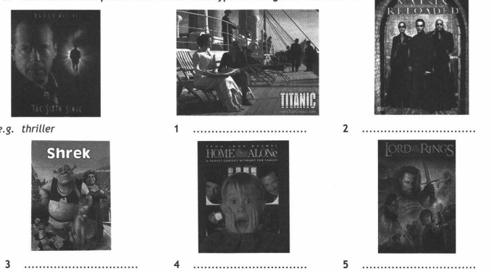
В). Complete the sentences with the correct film genre.
6. What a creepy …. …. !
7. It was such a funny ……….. !
8. What a great futuristic ……….. film!
9. Kids love ……………….. like Shrek.
C). Write an F next to the words relating to film, and an M next to those relating to music.
10. plot ……
11. lyrics ……
12. script …
13. powerful voice …….
14. special effects …….
15. single ………
16. music charts ……
17. acting ………
D). Underline the correct item.
18. Madonna is more famous/most famous than Beyonce.
19. I prefer classical music because it is more relaxing/most relaxing than rock music.
20. In my opinion, people who write songs are often most talented/more talented than singers.
21. This film is the most successful/more successful film ever!
E). Complete the table.
Adjectives | Comparatives | Superlatives
22) | taller (than) | 23)
famous | 24) | 25)
26) | 27) | (the) most talented
successful | 28) | 29)
F). Complete the dialogues using the Past Simple or the Present Perfect of the verbs in brackets.
B: Yes! 30) ….…. (l/see)Titanic last year.
31) ….…… (l/love) the song ‘My heart will go on’. The lyrics were so romantic.
A: I never liked that song!
32) ………… (you/always/like) romantic songs and films?
B: Not really! 33) ….……. (l/watch) science fiction films when I was young.
A: 34) …………. (you/ever/see) the Matrix? It has a great soundtrack!
B: No, but 35) ………. (l/watch) The Lord of the Rings last week on TV and 36) ……… (l/think) the music was excellent.
A: Oh really? 37) ….…… (l/not/see) that yet.
G). Complete the sentences using always, ago, yet, for or since.
38.I’ve been a fan of Harry Potter ….…. 2001.
39. They have been married …….. fifty years!
40. I lived in England two years ….…. .
41. Have you heard his new song ……. ?

H). Fill in the gaps with in, into, off or on.
- They used special effects to show how the woman turned ….….. a monster.
43. Don’t turn ……. the radio. I love this song!
44. I will turn ……. the TV as soon as I finish my homework.
45. I’m going to turn …….. I’m very tired!

Контрольно-измерительные материалы по английскому языку для 7 класса по УМК «Английский в фокусе» (Spotlight 7)
за IV четверть.

Spotlight 7. Модуль 8 «Green Issues». (Проблемы экологии).
  - Контроль лексико- грамматических знаний по теме «Проблемы экологии». Модуль 8
A). Fill in the correct word.
• pollution • fumes • trees • rubbish • recycle • rain • clean out
- ………. newspapers and cans
- toxic ….………
- air, water and soil ……………
- collect … ….
- acid …………..
- plant ………….
- …. ……… a pond
В). Match the phrases above with the correct picture.
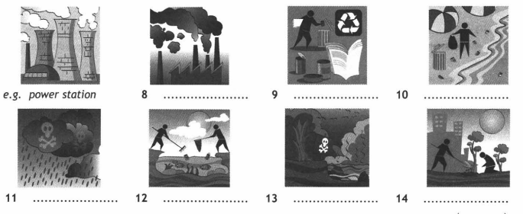
C). Underline the correct item.
- Water pollution can wipe out/drink up fish and plant species.
- I can’t make up/out what it says here.
- Acid rain gathers/poisons trees and plants.
- Solar/Oxygen power can be used to heat homes.
- Can I join/volunteer the Eco–helpers club?

D). What does/doesn’t Sarah have to do today?
- Call Mum. DONE. E.g. Sarah doesn’t have to call her mum.
- collect cans and newspapers today
- Take cans and newspapers to the recycling centre.
Apply to volunteer at the Eco–club.
- help clean the local pond
E). Complete the sentences using the Present Perfect Continuous form of the verbs in brackets.
- He … …… the environment for over ten years. (study)
- We ………. hard to build nesting boxes. (work)
- It …… ……. for two days. (rain)
- He …… ……. money to Greenpeace for a long time, (donate)
- The government … ……. to reduce pollution for years. (try)
- I …….……… to clean out ponds for a year now! (volunteer)
F). Fill in the question tag.
- Camels live in the desert, ………. ?
- Sarah didn’t collect the cans and newspapers, ………… ?
- Sarah has called her mum, … ….. ?
- Gorillas are amazing animals, …….. ?
- It can’t be true, ……….. ?

2)Контроль навыков чтения и аудирования «Время покупок» Модуль 9
I). Read the email and answer the questions.
Dear John,
I’m sorry that you could not come to my birthday party last weekend. We prepared all week for the party and there was a lot of food! Martin helped me with the planning. He decorated the living room and did the shopping.
Dad bought me a notebook which I really needed and Anna, my sister, bought me a great shirt with black and white stripes. Anna is the manager of a clothes shop so she knows what is in fashion. I wore it for the party and it looked really cool! I hope I get to see you soon!
Regards,
Ben
1.How long did Ben and Martin prepare for the party? ….
2.How did Martin help? …
3. Which shops did Ben’s presents come from? (2 answers)
4.What is Anna’s job? ……
J). Listen to Tina and Jake talk about shopping at the airport on their way back from Paris. Who bought each pair of things?
E.g. D Tina A) picture frame and wallet
6.……. Jake. – В) wallet and T–shirt
7……. Timothy. –C) chocolate and book
8……. Mike. – D) towel and teddy bear
9……. Bob. – E) chocolate and sunglasses
10…….. Nancy. – F) socks and swimsuit
G) book and postcards

3)Контроль лексико- грамматических знаний по теме « Время покупок». Модуль 9
A). Use the words/phrases to complete the sentences.
• cashier • shop assistant • security guard • cleaner
- A …………. protects the shop.
- A ………….. collects the money when people pay.
- A ………….. helps customers.
- A …………. cleans the shop.
B). Match the pictures to the shops.
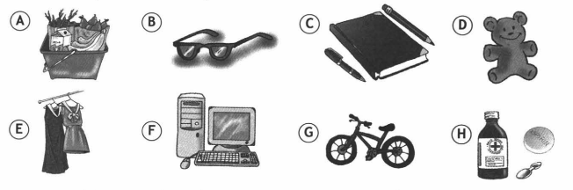
- chemist’s ……..
- stationery shop ……..
- toy shop ………
- clothes shop ………
- optician’s ………
- electronics shop ……….
- sports shop ………

C). Underline the correct item.
- The mirror had a big crack in it, so we took it back/away to the shop.
- Tom bought a beautiful ring for his wife from the homeware/jewellery shop.
- I saw the coolest glasses at the optician’s/chemist’s.
- I need to go to the stationery/electronics shop to buy a battery for my MP3 player.
- Take out/off your jumper and put it into the washing machine.
D). Put the items from the shopping list into the correct categories.
Shopping list: chocolate; bread; tomatoes; coffee; yoghurt; tea; bananas; crisps; chicken; cereal; lamb chops; peppers.
Meat & poultry 17) ……..
Dairy products 18) ……..
Beverages 19) …….
Cereals, grains & pasta 20) …….
Snacks 21) ………
E). Complete the sentences with carton, box, jar, cup, glass or bottle.
- The honey came in a big ………… .
- Can you pass me the ………. of cereal?
- Shall we buy a ………….. of water?
- Can I have a …………… of juice, please?
- I’d love a …………… of tea!
F). Underline the correct quantifier.
- I need some/any boxes.
- We haven’t got much/few time.
- There are much/а lot of skirts to choose from!
- There is any/some juice in the glass.
- There isn’t many/any coffee left.

G). Complete the sentences using the Present Perfect or the Present Perfect Continuous.
- Justin ………. dinner for two hours now! (cook).
- She …………. a present for you. (buy).
- They ……….. their holiday for the last two weeks. (plan)
- I …… …….. Jack for six years. (know)
- You …… ……… all morning! (pack)

4) Контроль навыка письма и говорения по теме «В здоровом теле – здоровый дух» (Модуль 10).
A). Use the prompts to complete the phrases.
• throw • lose • argue • move • sit
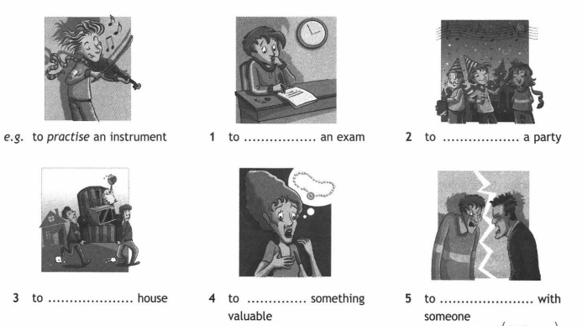

- to ……..…. an exam
- to …… ……. a party
- to …… …….. house.
- to …… …… something valuable
- to ……. …….. with someone
В). Match the words in Column A to the words in Column B.
E.g. wash E A. a light meal
- put ….. В. plenty of fluids
- drink ….. C. some rest
- eat ….. D. a painkiller
- get ….. E with cold water
- take ….. F. a cold pack on your forehead

C). Fill in the correct word.
• sore• ache• chip• flu• sprain• hurt• appointment
- Can I have some honey, please? My throat is …… ……. .
- I have a(n) ….. ……. to see the doctor this afternoon.
- I have a high temperature. I think I am coming down with the ….. ……. .
- John has …… ……. his back and has to rest.
- Polly didn’t go to school today as she had a stomach …… ……
- When you ….. …… a tooth you have to go to the dentist.
- What happened? Did you …… ……. your wrist?

D). Underline should or shouldn’t.
- Alex should/shouldn’t pick up that heavy box. He is going to hurt his back.
- I should/shouldn’t do more exercise to feel better.
- You should/shouldn’t be nervous. You revised well for the test.
- We should/shouldn’t panic. There is still plenty of time to get there.
- They should/shouldn’t wear their sunglasses or they will get sore eyes.
- I think I am getting a cold. I should/shouldn’t take some vitamin C tablets.
- She should/shouldn’t go to the doctor. She doesn’t look well.
- Paula should/shouldn’t worry. She always does well at Maths.
- If you are tired, you should/shouldn’t go to bed early tonight.
- We should/shouldn’t fight. We are best friends!
E). Fill in the gaps with apart, behind or out.
- Tim has fallen ….….. with Sam because he broke his MP3 player.
- She fell ….…… with her schoolwork when she was ill.
- The bookcase fell ……… as soon as we placed some books on it.
F). Write the correct reflexive pronoun in the gap.
- Did you hurt ……. badly in the accident?
- I made the meal ….…….
- We don’t need any help. We are going to do it ……… .
- He usually goes to the gym by ……………
- The computer switched off by ………….
- The new teacher introduced ………. to the class.
- Tina cut ………….. with the knife by accident.
- The doctor told Chloe and Alex to look after ……..
- Do you think she can do it by ………….?
- We are going shopping by …………..

G). Choose the correct response.
E.g. Have you been to the doctor yet? F A) Everything will be all right. You revised well.
- Are you all right? … B) Yes, I’m fine, thank you.
- Is something wrong? … C) Let me help you.
43.Doctor, how bad is it? D) No. Why? Do I look stressed?
44.I’m worried about the exams. E) It’s nothing serious.
45.I don’t have time to finish this by myself! … F. Yes. He gave me antibiotics

Ключи
Контрольно-измерительные материалы по английскому языку для 7 класса по УМК «Английский в фокусе» (Spotlight 7).
I четверть.
1)Контроль навыков чтения и аудирования Mодуль 1.
1. Reading (Testbooklet 7 m1. H)
1-F 2-Т 3-Т 4-F 5-Т 6-F 7-Т 8-Т 9-Т 10-F.
2. Listening (Testbooklet m1. I)
11-bed 12-garden 13-high 14-stranger 15-sure.
Итого: 15 баллов («5» - 15-14 баллов; «4» - 13-12 баллов; «3»- 11-8 баллов; «2»- 7-0 баллов)
2)Контроль лексико- грамматических знаний . Модуль 1
Testbooklet 7 m1 (A,B,C,D,E,F,)
А). 1-Е 2-F 3-В 4-А 5-С.
В). 6-Е 7-D 8-В 9-С 10-А.
С). 11-peace 12-crowded 13-helpful 14-heavy 15-cost.
D). 16-over 17-into 18-of 19-out 20-after.
Е). 21-feed 22-is thinking 23-leaves/is leaving 24-are going 25-am studying 26-starts 27-leaves 28-am cooking 29-visits 30-is writing.
F). 31-You should keep it in your pencil case. 32-You shouldn’t play outside. 33-You should see a dentist. 34-You shouldn’t worry so much. 35-You should tell him tonight.
Итого: 35 баллов («5» -35-30 баллов, «4» -29-24 баллов, «3» 23-15 баллов, «2»- 14-0 баллов)

3)Контроль письма и говорения. Модуль 2
Testbooklet 7 m2 (A,B,C,D,E)
А). 1-Е 2-G 3-F 4-С 5-В 6-А.
В). 7-solve 8-famous 9-imagination 10-glance 11-intelligent 12-cosy 13-explore 14-hide 15-compass 16-initials.
С). 17-wrote 18-smoked 19-caught 20-Did Hercule Poirot live 21-did Captain Nemo travel 22-Did Dr Watson help 23-created 24-found 25-was 26-met.
D). 27-as soon as 28-went 29-used to go 30-when 31-after 32-then 33-until.
E). 34-А 35-С 36-F 37-В 38-Е.
Итого: 38 баллов («5» -38-33 баллов, «4» -32-29 баллов, «3» 28-20 баллов, «2»- 19-0 баллов)
II четверть.
1)Контроль навыков аудирования и чтения. Модуль 3
Testbooklet 7 m3 (G,H)
I).1-a 2-b 3-c 4-c 5-b.
H).6-F 7-Т 8-F 9-Т 10-Т.
Итого: 10 баллов («5» -10-9 баллов, «4» -8-7 баллов, «3» 6-5 баллов, «2»- 4-0 баллов)
2)Контроль лексико – грамматических навыков. (Модуль 3).
Testbooklet 7 m3 (A,B,C,D,E,F)
А). 1-curious 2-determined 3-patient 4-athletic 5-daring.
В). 6-spiky 7-tans 8-well-built 9-hair 10-pigtails 11-long 12-moustache 13-freckles 14-shoulder-length 15-curly.
С). 16-who 17-where 18-why 19-whose 20-when.
D). 21-boring 22-disappointed 23-interesting 24-tired 25-scared.
Е). 26-nice middle-aged English 27-interesting young Japanese 28-famous well-built Russian 29-easy-going tall French 30-talented teenage Italian 31-pretty intelligent German.
F). 32-up 33-back 34-away
Итого: 34 баллов («5» -34-30 баллов, «4» -29-24 баллов, «3» 23-15 баллов, «2»- 14-0 баллов)
3)Контроль навыка говорения и письма. Модуль 4.
Testbooklet 7 m4 (A,B,C,D, E,F)
A). 1-news 2-weather report 3-interview 4-Chat show 5-Cartoon.
В). 6-gossip 7-music 8-Horoscopes 9-text messages 10-fashion.
С). 11-bravely 12-ran off 13-surprised 14-up 15-excited 16-report 17-attractive 18-advice 19-break 20-with.
D). 21-were planning 22-was taking 23-were working 24-were you doing 25-was playing.
Е). 26-was riding 27-were you doing 28-passed 29-cooked 30-was writing 31-went 32-found 33-played 34-was driving 35-got dressed.
F). 36-E 37-D 38-A 39-B 40-C
Итого: 40 баллов («5» 40-35 баллов, «4» 34-26 баллов, «3» 25-19 баллов, «2»- 18-0 баллов)
III четверть.
1)Контроль лексико- грамматических знаний . Модуль 5.
Testbooklet 7 m5 (A,B,C,D,E)
А). 1-laptop 2-button 3-assignment 4-gadgets 5-submarines.
В). 6-E 7-D 8-B 9-F 10-A.
C). 11-button 12-role model 13-pocket money 14-training 15-Computer simulation.
D). 16-’ll go 17-going to 18-will 19-will 20-’m going to.
Е). 21-do not/don’t study 22-will/’ll buy 23-run 24-will/’ll have 25-will not/won’t have to 26-cook 27-will/’ll invite 28-is 29-rains 30-do not/don’t sleep.
Итого: 30 баллов («5» 30-26 баллов, «4» 25-19 баллов, «3» 20-15 баллов, «2»- 14-0 баллов)
2)Контроль навыков аудирования и чтения. Модуль 6
Testbooklet 7 m6 (I,J)
I). 1–А 2–С 3–А 4–С 5–А 6–В.
J). 7–А 8–D 9–Е 10–В 11–F.
Итого: 11 баллов («5» -11-10 баллов, «4» -9-8 баллов, «3» 7-5 баллов, «2»- 4-0 баллов)
3) Контроль лексико- грамматических знаний. Модуль 6
Testbooklet 7 m6 (A,B,C,D,E,G)
А). 1–D 2–С 3–А 4–F 5–В.
В). 6–fly 7–see 8–shake hands 9–explore 10–go 11–eat.
С). 12–true 13–Greetings 14–irresponsible 15–logical.
D). 16–across 17–back 18–out 19–round.
E). 20–already 21–yet 22–never 23–just 24–before.
F). 25–been 26–gone 27–been 28–gone 29–been.
G). 30 – Has your teacher been to England?
31 – They have never ridden on a rollercoaster.
32 – My best friend has never been to Italy.
33 – Have you ever explored a haunted mansion?
34 – Has he ever visited The Great Wall of China?
35 – I have never flown in a helicopter.
Итого: 35 баллов («5» -35-30 баллов, «4» -29-24 баллов, «3» 23-15 баллов, «2»- 14-0 баллов)

4) Контроль навыка говорения и письма. (Модуль 7).
Testbooklet 7 m7 (A,B,C,D,E,F,G,H)
А). 1–romance 2–science fiction 3–animation/cartoon 4–comedy 5–fantasy.
B). 6–thriller 7–comedy 8–science fiction 9–animations/cartoons.
C). 10–F 11–M 12–F 13–M 14–F 15–M 16–M 17–F.
D). 18–more famous 19–more relaxing 20–more talented 21–most successful.
E). 22–tall 23–(the) tallest 24–more famous (than) 25–(the) most famous 26–talented 27–more talented (than) 28–more successful (than) 29–(the) most successful.
F). 30–I saw 31–I loved 32–Have you always liked 33–I watched 34–Have you ever seen 35–I watched 36–I thought 37–I haven’t seen.
G). 38–since 39–for 40–ago 41–yet.
Н). 42–into 43–off 44–on 45–in.
Итого: 45 баллов («5» -45-40 баллов, «4» -39-30 баллов, «3» 29-19 баллов, «2»- 18-0 баллов)
IV четверть.
1)Контроль лексико - грамматических знаний . Модуль 8
Testbooklet 7 m8 (A,B,C,D, E,F)
А). 1–recycle 2–fumes 3–pollution 4–rubbish 5–rain 6–trees 7–clean out.
B). 8–toxic fumes 9–recycle newspapers/cans 10–collect rubbish 11–acid rain
12–clean out a pond 13–air, water and soil pollution 14–plant trees.
C). 15–wipeout 16–out 17–poisons 18–Solar 19–join.
D). 20–Sarah doesn’t have to collect cans and newspapers today.
21–Sarah has to take cans and newspapers to the recycling centre.
22–Sarah has to apply to volunteer at the Eco-club.
23–Sarah doesn’t have to help clean the local pond.
E). 24–has been studying 25–have been working 26–has been raining
27–has been donating 28–has been trying 29–have been volunteering.
F). 30–don’t they 31–did she 32–hasn’t she 33–aren’t they 34–can it.
Итого: 34 баллов («5» -34-30 баллов, «4» -29-24 баллов, «3» 23-15 баллов, «2»- 14-0 баллов)
2)Контроль навыков чтения и аудирования . Модуль 9
Testbooklet 7 m9 (I,J)
I). 1–One week. 2–Martin helped with the planning–He also decorated the living room and did the shopping.
3–Stationery shop. 4–Clothes shop. 5–Manager of a clothes shop.
J). 6–А 7–В 8–Е 9–G 10–F.
Итого: 10 баллов («5» -10-9 баллов, «4» -8-7 баллов, «3» 6-5 баллов, «2»- 4-0 баллов)
3)Контроль лексико - грамматических знаний . Модуль 9
Testbooklet 7 m9 (A,B,C,D,E,F,G)
А). 1–security guard 2–cashier 3–shop assistant 4–cleaner.
В). 5–H 6–С 7–D 8–Е 9–В 10–F 11–G.
С). 12–back 13–jewellery 14–optician’s 15–electronics 16–off.
D). 17–chicken, lamb chops 18–yoghurt 19–coffee, tea 20–bread, cereal 21–chocolate, crisps.
E). 22–jar 23–box 24–bottle 25–glass 26–cup.
F). 27–some 28–much 29–a lot of 30–some 31–any.
G). 32–has been cooking 33–has bought 34–have been planning 35–have known 36–have been packing.

Итого: 36 баллов («5» -36-31 баллов, «4» -30-23 баллов, «3» 22-16 баллов, «2»- 17-0 баллов)
4) Контроль навыков письма и говорения. Модуль 10.
Testbooklet 7 m10 (A,B,C,D,E,F,G)
А). 1–sit 2–throw 3–move 4–lose 5–argue.
В). 6–F 7–B 8–A 9–C 10–D
С). 11–sore 12–appointment 13–flu 14–hurt 15–ache 16–chip 17–sprain.
D). 18–shouldn’t 19–should 20–shouldn’t 21–shouldn’t 22–should
23–should 24–should 25–shouldn’t 26–should 27–shouldn’t.
E). 28–out 29–behind 30–apart.
F). 31–yourself 32–myself 33–ourselves 34–himself 35–itself
36–herself/himself 37–herself 38–themselves 39–herself 40–ourselves.
G). 41–В 42–D 43–Е 44–А 45–С.
Итого: 45 баллов («5» -45-40 баллов, «4» -39-30 баллов, «3» 29-19 баллов, «2»- 18-0 баллов)

